**Screenshots of Projector Booking**

***REST API documents***

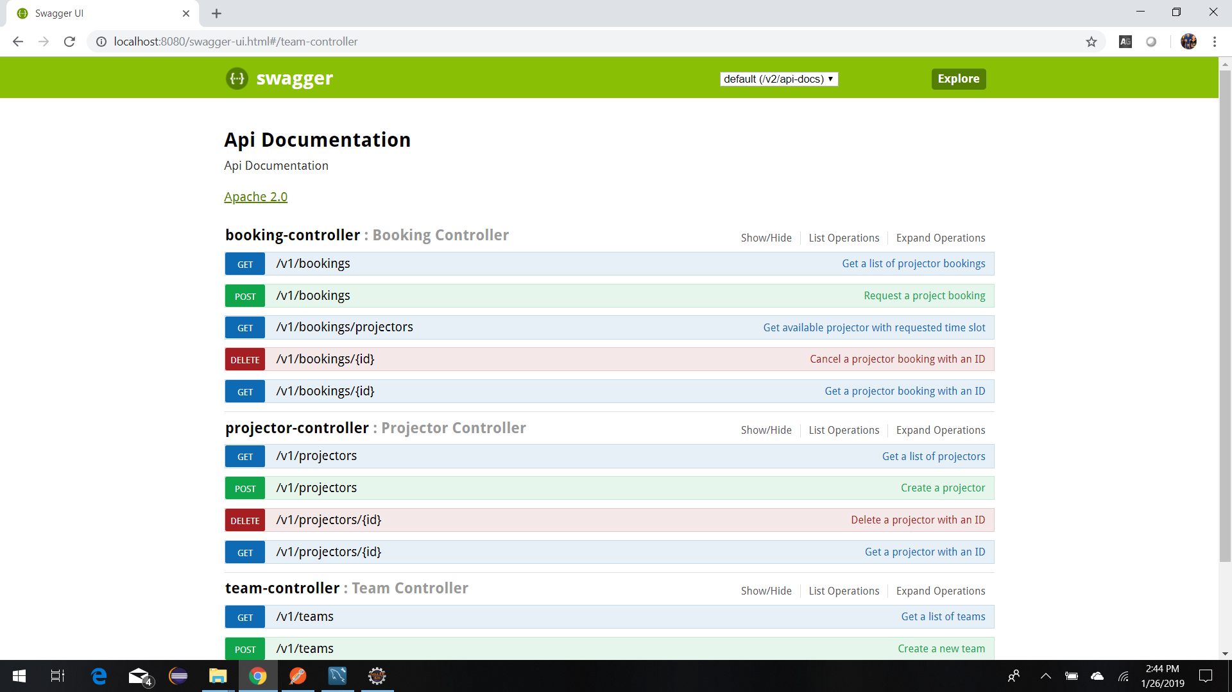

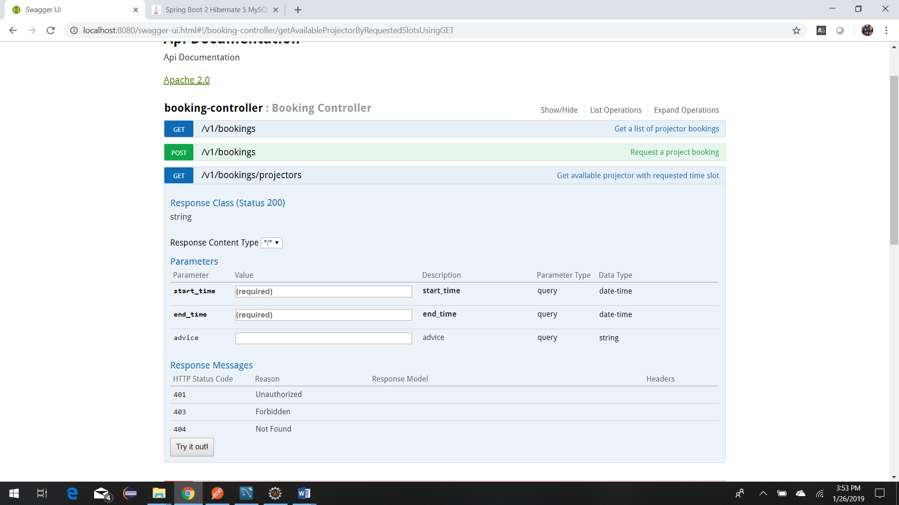

***Scenarios***

Prerequisites:

Before testing the following scenarios, we need to create three projectors: projector1, projector2, projector3 and five teams: team1, team2, team3, team4, team5.

* Create Projector1

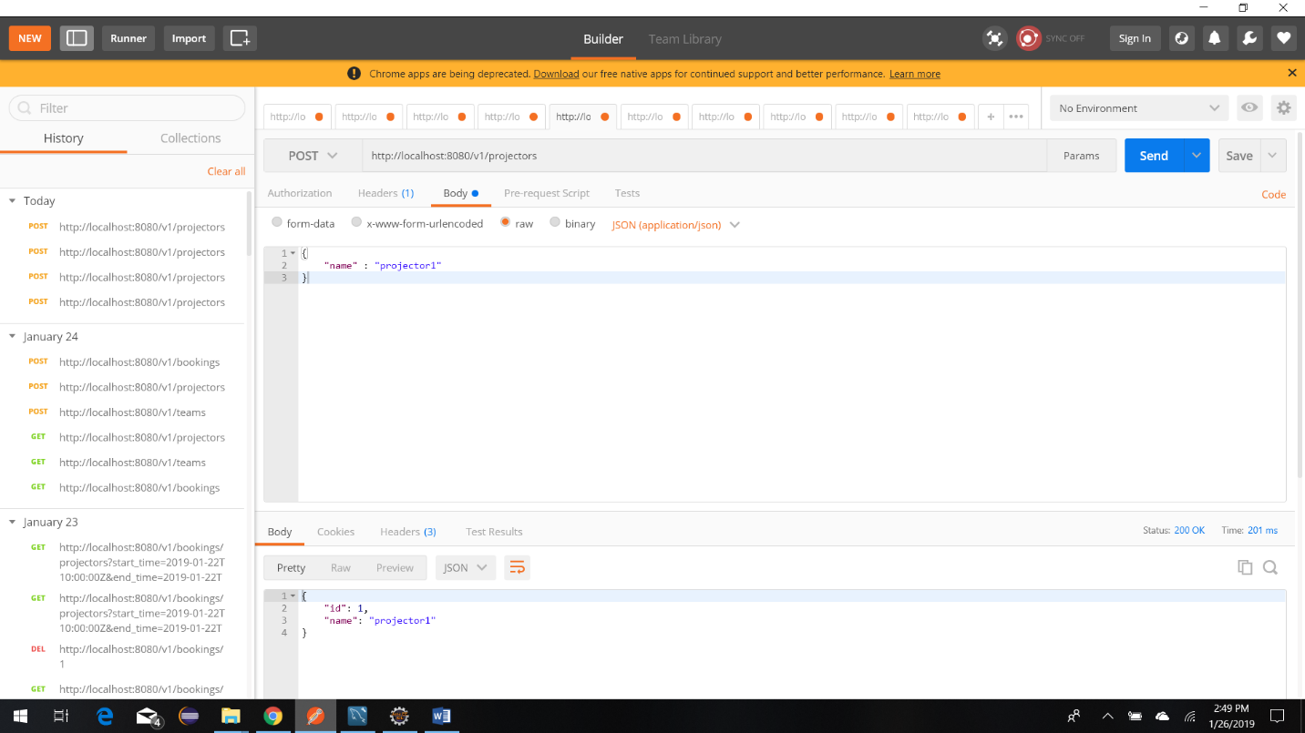

* Create Projector2

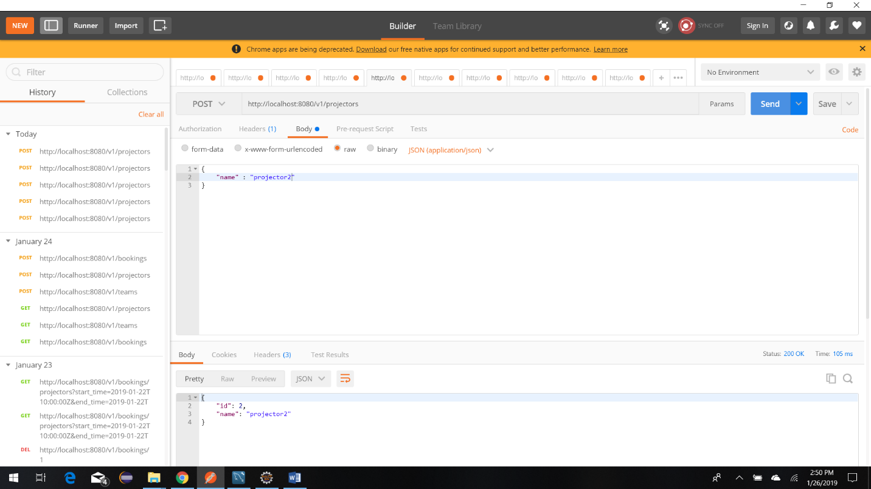

* Create Projector3

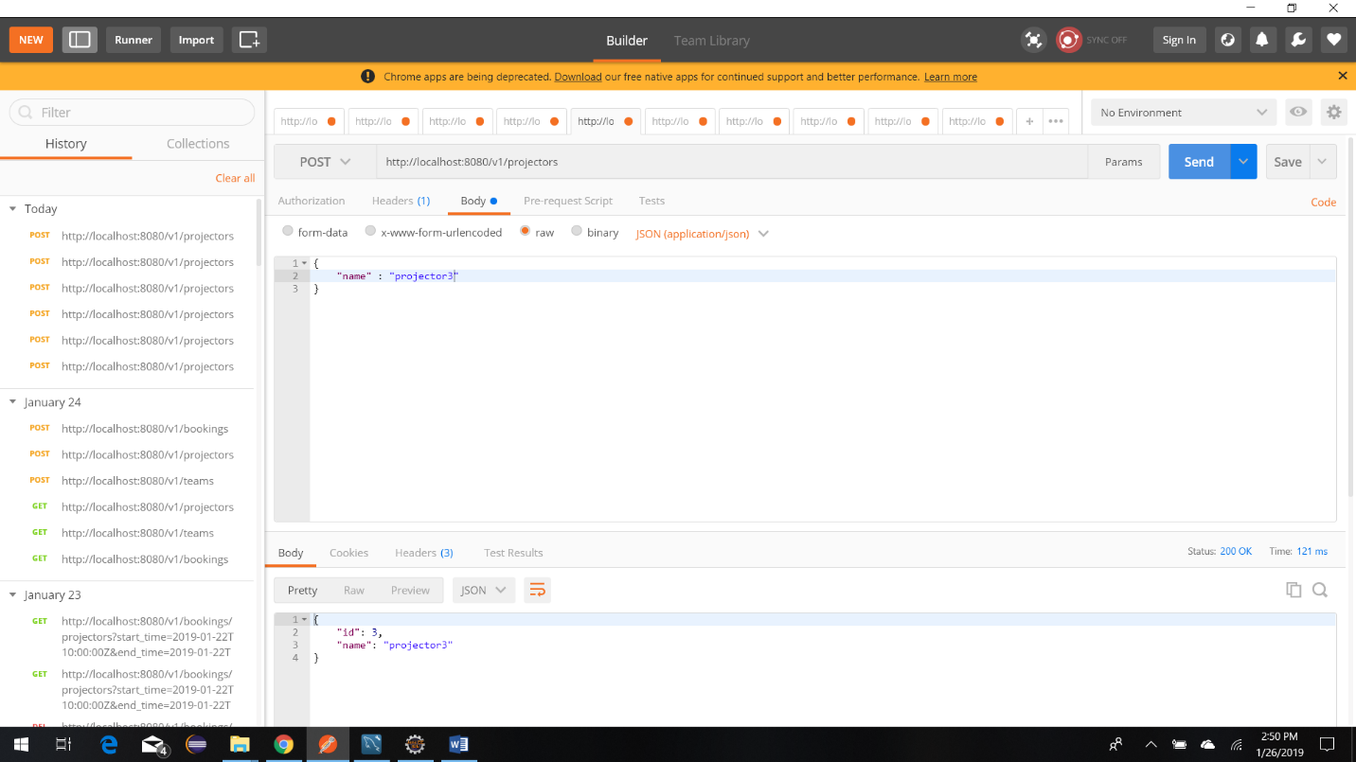

* Create Team1

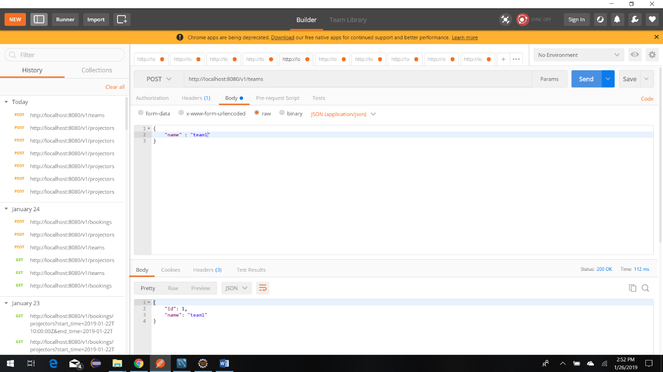

* Create Team2

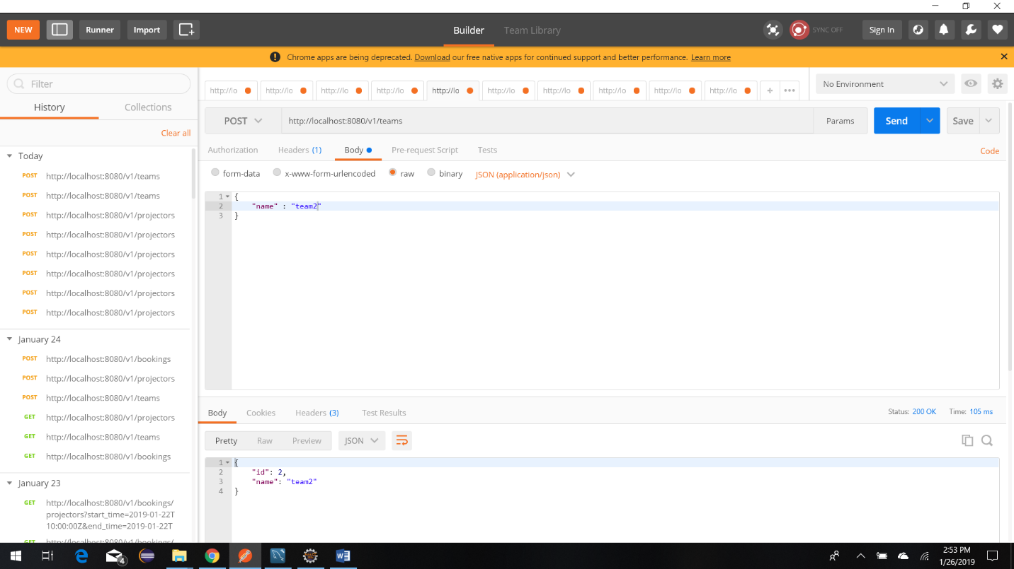

* Create Team3

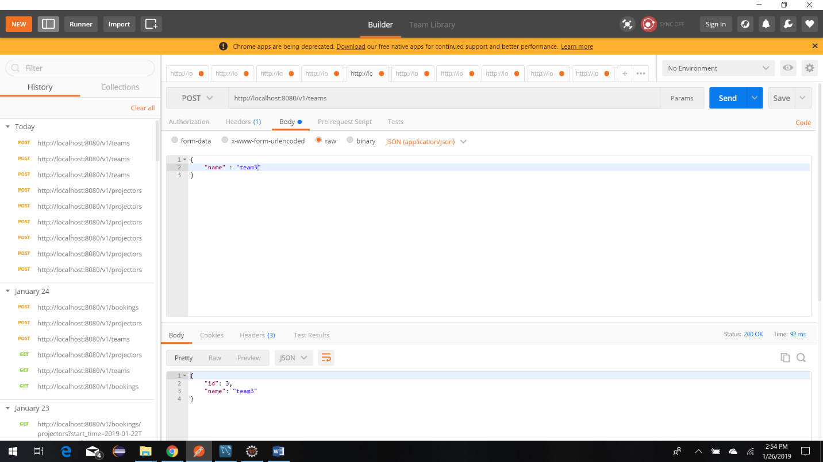

* Create Team4

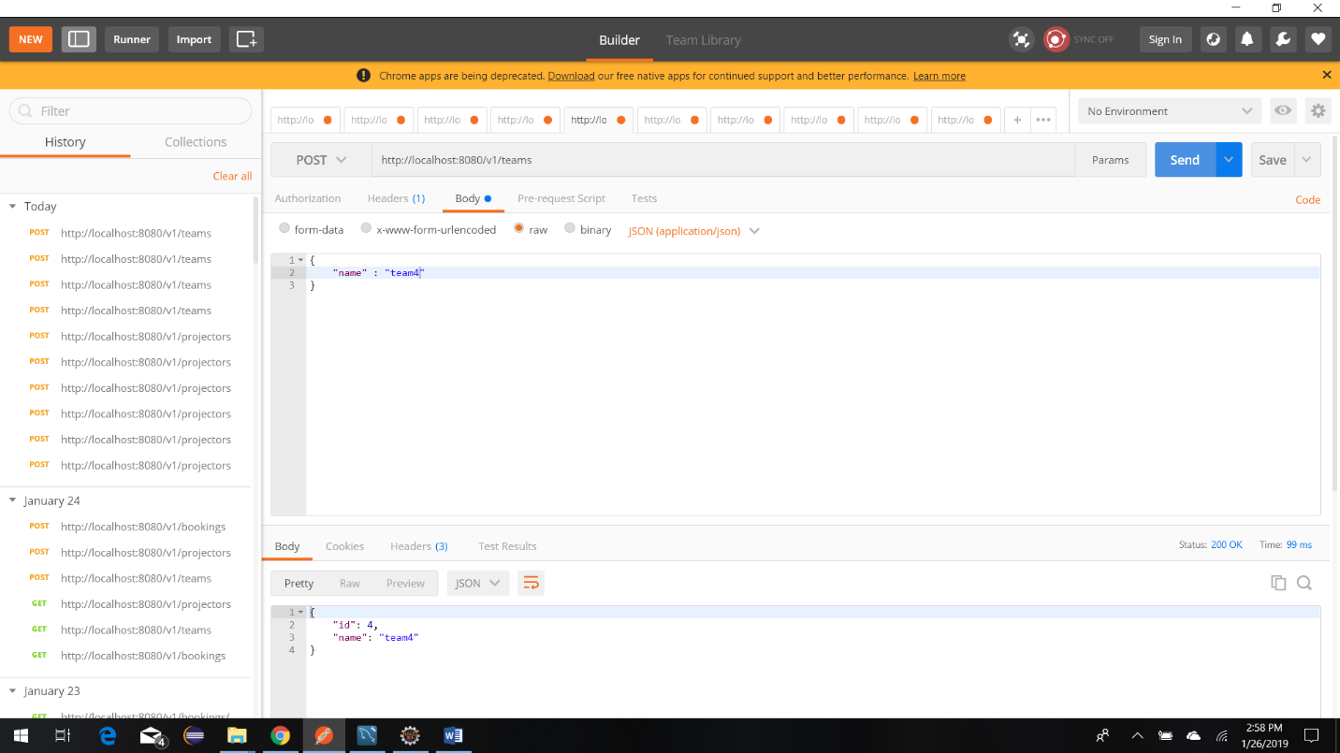

* Create Team5

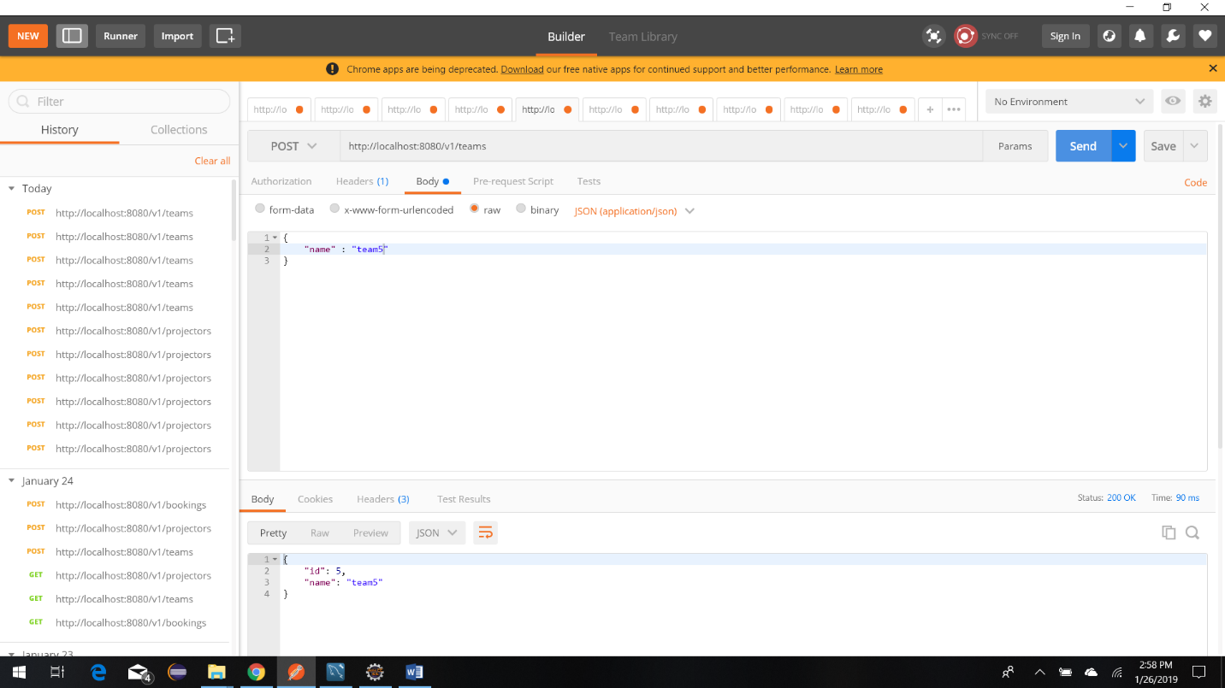

Scenario 1: Team1 requests a projector on a given date from 10:00 am to 12:00 pm => (System can assign P1)

First Check availability of projectors for the time slot from 10:00am to 12:00pm and find ‘Projector1’

<http://localhost:8080/v1/bookings/projectors?start_time=2019-01-25T10:00:00Z&end_time=2019-01-25T12:00:00Z>

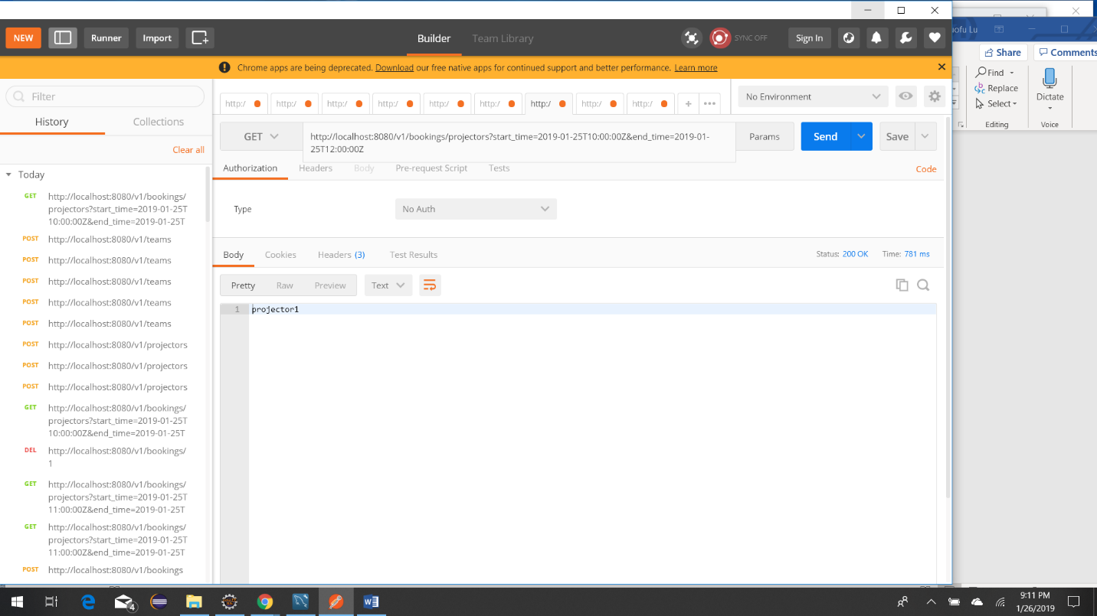

Second, Book the ‘Projector1’ with Team1 for the time slot

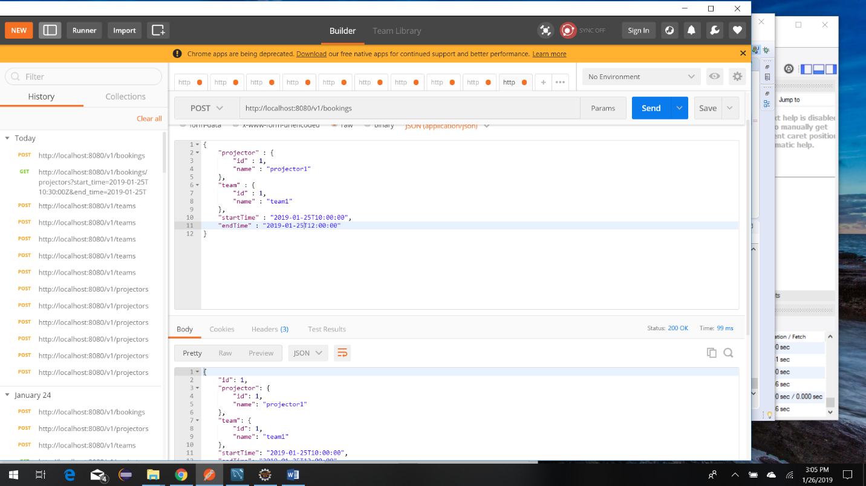

Scenario 2: Team2 requests a projector on the same day from 10:30 am to 11:30 am => (System cannot assign P1 as it is overlapping with Team1’s reserved slot, but it can assign P2)

First check availability of projectors for the time slot from 10:30 am to 11:30 am, and find projector2

<http://localhost:8080/v1/bookings/projectors?start_time=2019-01-25T10:30:00Z&end_time=2019-01->25T11:30:00Z

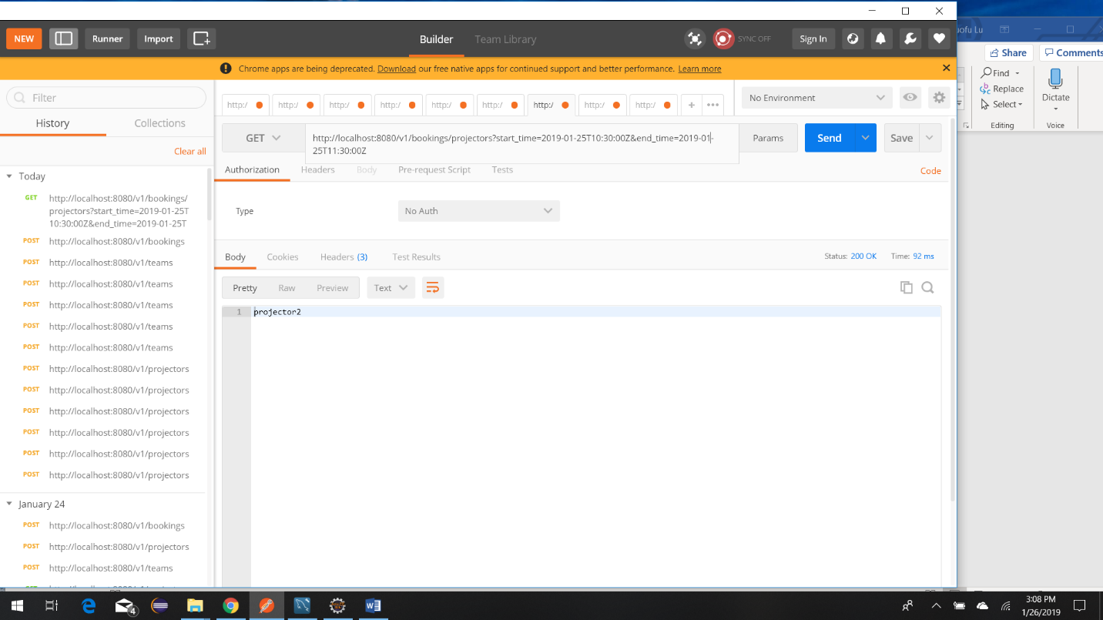

Second, Book the ‘Projector2’ with Team2 for the time slot

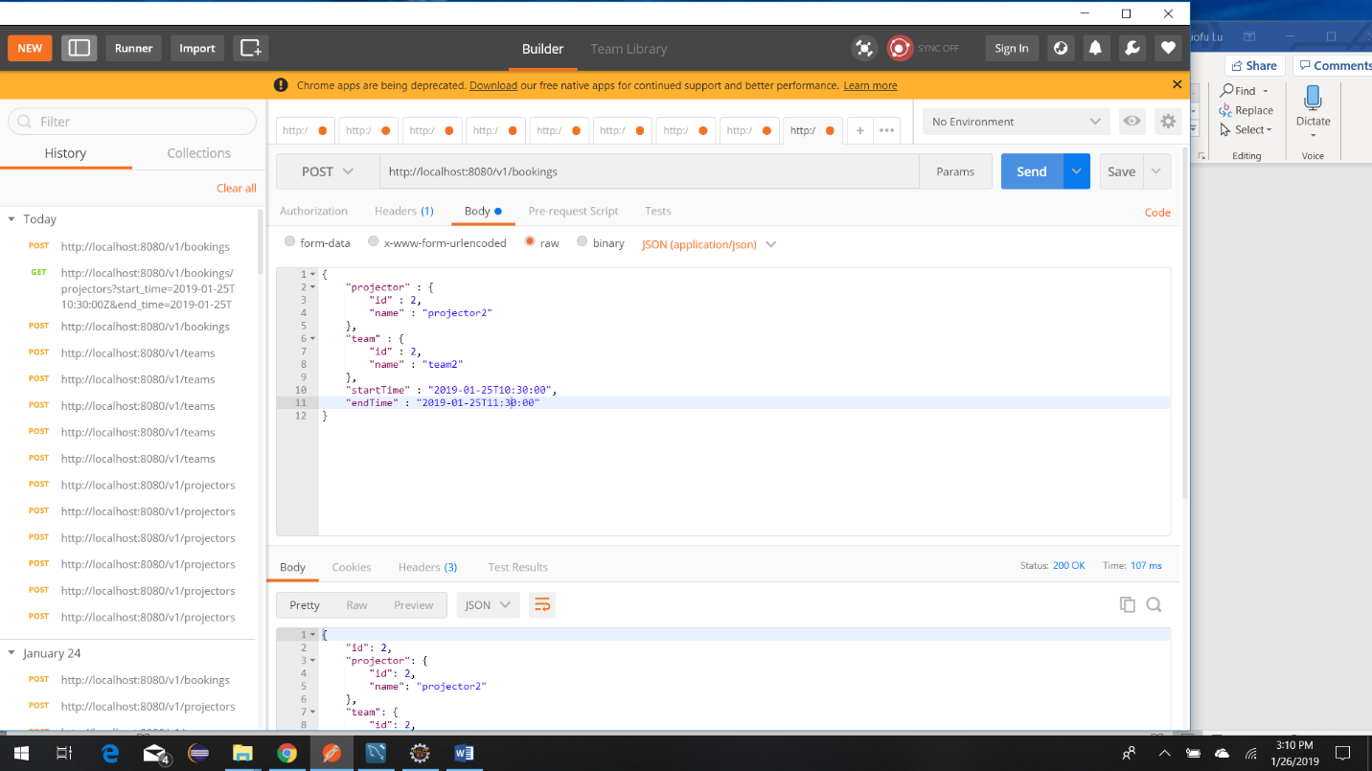

Scenario 3: Team3 requests a projector from 11:10 am to 12:00 pm => (System cannot assign P1 or P2 but can assign P3, etc.)

First check availability of projectors for the time slot from 11:30 am to 12:00 am, and find projector3

<http://localhost:8080/v1/bookings/projectors?start_time=2019-01-25T11:30:00Z&end_time=2019-01->25T12:00:00Z

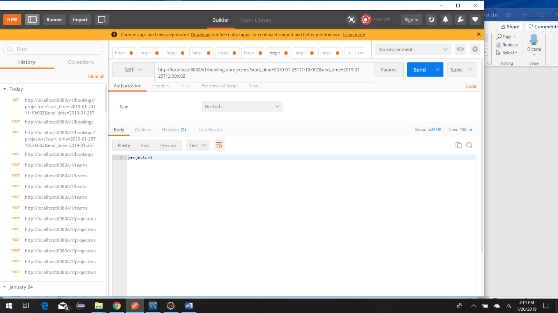

Second, Book the projector3 and team3 for the time slot

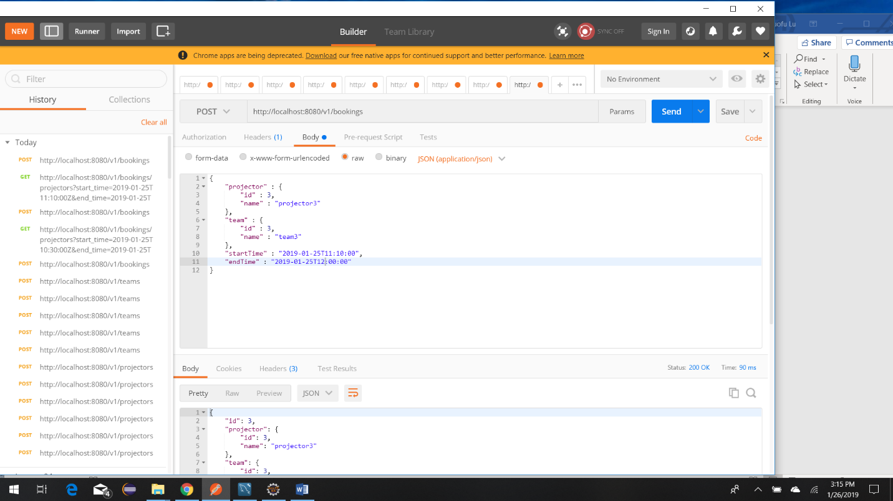

Scenario 4: Team4 requests a projector between 11:00 am - 11:30 am => (System cannot assign any projectors now since they’re all taken)

Check availability of projectors for the time slot from 11:00 am to 11:30 am, and can not find any projector.

http://localhost:8080/v1/bookings/projectors?start_time=2019-01-25T11:00:00Z&end_time=2019-01-25T11:30:00Z

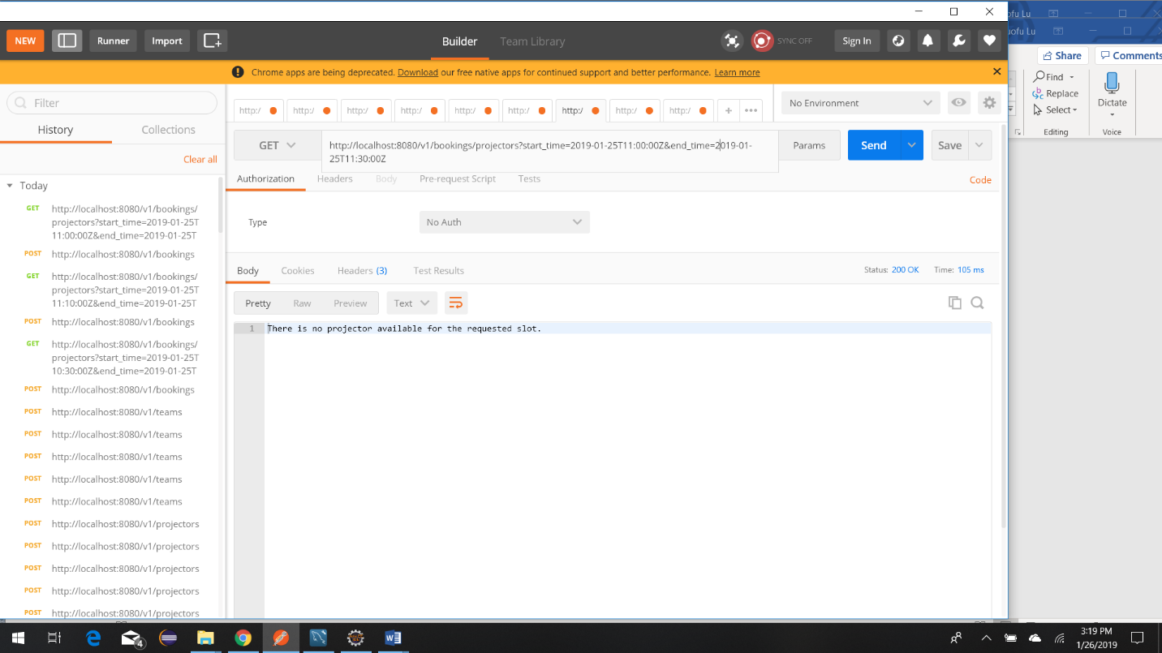

With extensibility of future requirements, I added optional ‘advice’ request parameter. By setting advice=true, it shows the proposed new start time

<http://localhost:8080/v1/bookings/projectors?start_time=2019-01-25T11:00:00Z&end_time=2019-01-25T11:30:00Z&advice=true>

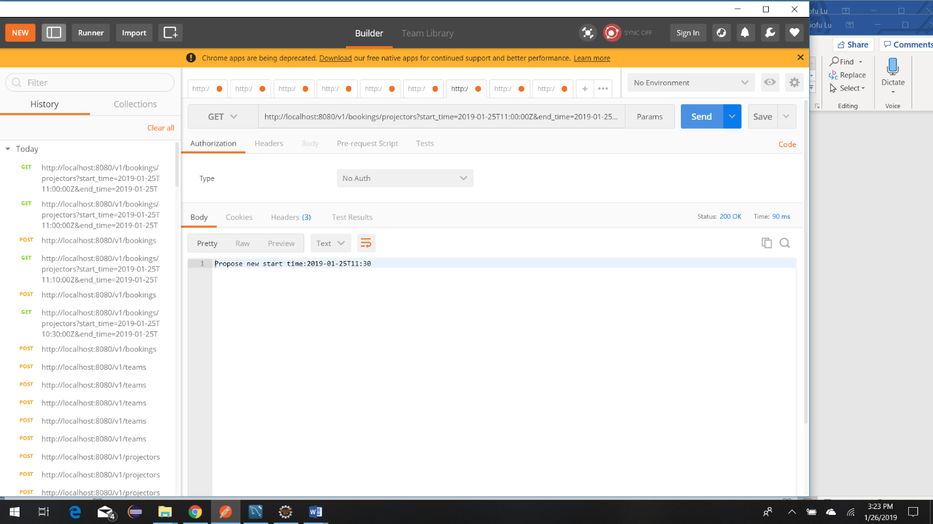

Scenario 5: Team1 cancels their 10am - 12pm slot => System frees up P1

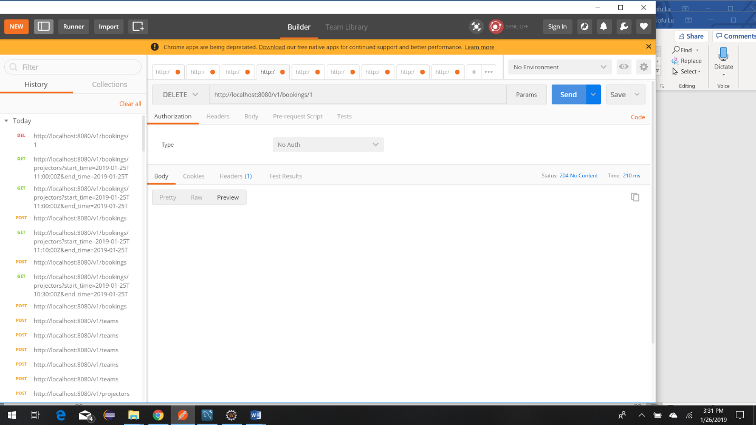

Scenario 6: Team4 wants a projector between 10am and 11am => System assigns P1

First, Check availability of projectors for the time slot from 10 am to 11 am, and find projector1.

<http://localhost:8080/v1/bookings/projectors?start_time=2019-01-25T10:00:00Z&end_time=2019-01->25T11:00:00Z

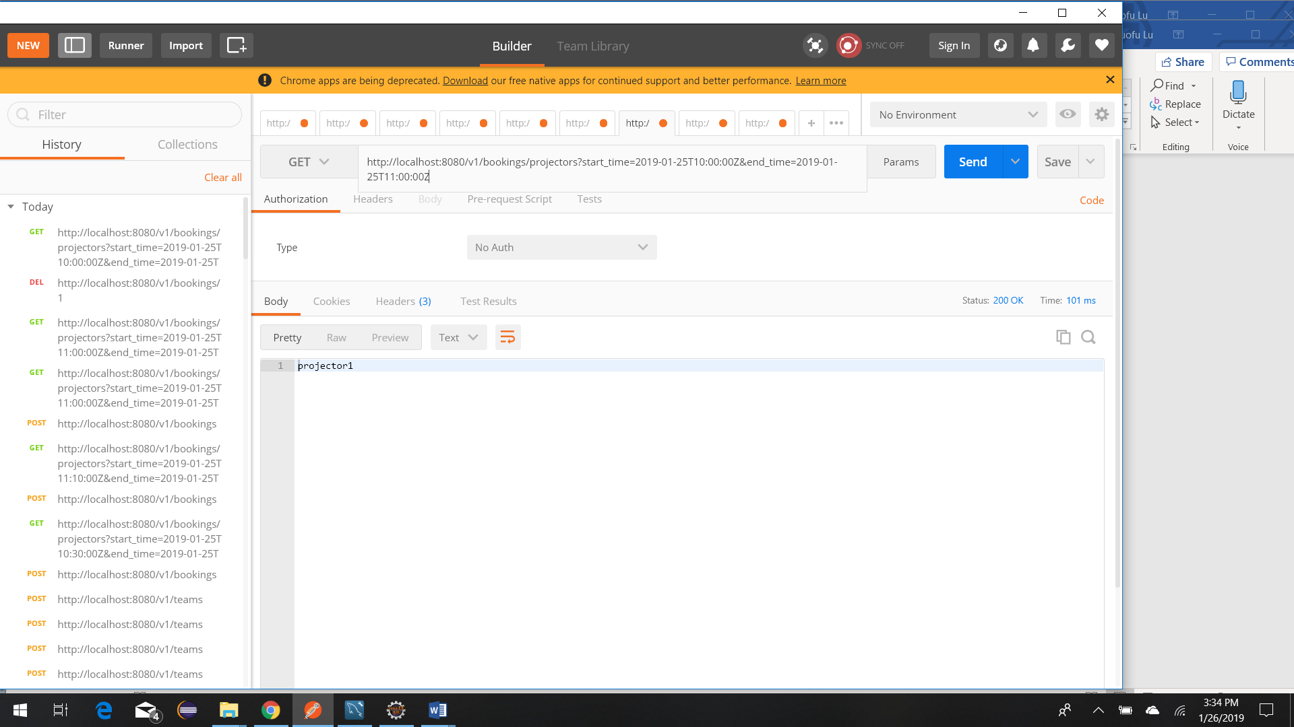

***REST API unit tests***

